There is far more to our history
than the Treaty of Waitangi.
New Zealand’s true Founding Document and First Constitution.

By Ross Baker, Researcher, One New Zealand Foundation Inc.
On the first page of Claudia Orange’s 1987 book, “The Treaty of Waitangi” is written, “Claudia Orange offers new interpretations of the Treaty in New Zealand History from 1840 to the present day”.
The problem is, they are her interpretations of the Treaty of Waitangi only and overlooks many of the vital events in New Zealand between 1840 and 1841. Most of our “professional historians and researchers”, including Claudia Orange have failed to venture further afield to find the Treaty of Waitangi did not make New Zealand into an independent British Colony under one flag and one law.
Queen Victoria’s Royal Charters/Letters Patent – Sovereignty by the Law Nations.
Six days before the Tiriti o Waitangi received its first signature/mark, Britain had claimed sovereignty over New Zealand by the “Law of Nations”. This was achieved by a beautifully prepared, written and presented Royal Charter/Letters Patent dated the 30 July 1839 issued by, “Victoria by the Grace of God” under “The Great Seal of the United Kingdom of Great Britain and Ireland”. New Zealand came under the laws and dependency of New South Wales on the 30 January 1840 with the Governor of New South Wales, Sir George Gipps the first Governor of New Zealand and Captain William Hobson, his Lieutenant Governor to New Zealand. See page 3.
The Declaration of Independence – A complete failure!
British Resident, James Busby had tried to get the chiefs to claim sovereignty over New Zealand by the 1835 Declaration of Independence. It stated the chiefs were to meet annually to form a united government to bring peace and trade between the tribes and settlers, but due to the ever-present intertribal fighting, it was abandoned 12 months later without one meeting taking place. The Declaration of Independence was a complete failure as the chiefs were not interested in forming a united government with a “Head of State” to claim sovereignty over New Zealand. See page 5.
Treaty of Waitangi - Hardly a Founding Document.
Dame Claudia Orange and her other “professional historians/researchers” tell the people of New Zealand the Treaty of Waitangi was our Founding Document, when in fact, it was scribbled on a piece of paper by a sea captain, translated into a primitive language that continually changes depending on how many dollars can be extract from the taxpayers and then, transcribed onto a piece of dog skin that was later damaged by fire and rats. Hardly a Founding Document!
The Treaty only cleared up the sovereignty Lord Normanby thought the tribes may have had over their everchanging territories that they had not already sold before the Treaty was signed. The Treaty of Waitangi was never intended to cede sovereignty as there was no sovereignty to cede, be our Founding Document or “A Partnership between Maori and the Crown”. See page 6 and 7.
Tangata Maori gave up their kawanatanga/governments to become British Subjects.
Once the sovereignty issue had been solved, over 500 tangata Maori chiefs agreed to give up their kawanatanga/governments to the Queen and in return; the majority of tangata Maori became British subjects with, “The same rights as the people of England”. No more – No less! English law does not allow a British subject to be, “In partnership with the Crown”.
British Sovereignty over New Zealand was announced on the 2 October 1840 in the London Gazette and has never been challenged by any other country or Nation.
Queen Victoria’s 1840 Royal Charter/Letters Patent – Our true Founding Document.
One month later, on the 16 November 1840 another beautifully prepared, written and presented Royal Charter/Letters Patent was issues by “Victoria by the Grace of God” under “The Great Seal of the United Kingdom of Great Britain and Ireland” that separated New Zealand from New South Wales. Lt. Governor Hobson became the second Governor of New Zealand on the 3 May 1841. See page 8.
This Royal Charter/Letters Patent made New Zealand into an independent British Colony on the 3 May 1840 with its first Constitution that set up New Zealand’s first government to make laws with courts and judges to enforce those laws under one flag and one law, irrespective of race colour and creed.
The professional historian/researchers mislead the Government and the People of New Zealand.
Very few “professional” historians/researchers, including Dame Claudia Orange have ever researched or published this vital part of our true history as they make no mention of it in any of their many books on New Zealand history. This has allowed the Treaty of Waitangi to be taken as our Founding Document by Governments, when in fact, it founded nothing except to clear up Lord Normanby’s misunderstanding of tangata Maori having sovereignty over New Zealand and made tangata Maori, “British subjects with the same rights as the people of England”.
As past historians have created a lot of damage to New Zealand with their “lazy research”, it’s time they apologised to the people of New Zealand and brought their research up to date.
Governments uses “lazy research” to defraud the taxpayers.
Their “lazy research” has been used by governments since the 1975 Treaty of Waitangi Act to allow breaches against the Treaty, but any breaches can only be against the laws of New Zealand as the Treaty had nothing to do with setting up our political, legal or justice systems. All claims by Maori should be heard in our Courts where the claimants can be cross-examined and not the apartheid Waitangi Tribunal where verbal evidence takes precedence over documented evidence and non-Maori cannot participate or lodge an appeal.
Government hides Royal Charters/Letters Patent.
Government has now supported this “lazy research” by dismantling our Constitution Room at Archives New Zealand on the 17 April 2017 and has filed/hidden Queen Victoria’s Royal Charters/Letters Patent of 1839 and 1840 in Archive’s Repository, where they must now be ordered if future researchers want to research our true history, that is, if they know Queen Victoria’s Royal Charters/Letters Patent exist.
The most corrupt act ever forced on the People of New Zealand by any government
This would be the most corrupt act ever forced on the people of New Zealand by any government, but our so called “professional historians/researches” such as Claudia Orange have either deliberately misled the Government and people of New Zealand or have been too lazy to research our true history which must include Queen Victoria’s Royal Charters/Letters Patent, our true Founding Documents and first Constitution that set up our political, legal and justice systems under one flag and one law, irrespective of race, colour or creed. See first Constitution page 9 and copy of disk supplied by the Chief Archivist, Archives New Zealand page 12.
I hope this clears up any misunderstanding of New Zealand’s true history. There is far more to our history than that researched and written by Dame Claudia Orange and the so called “professional historians and researchers”. They have misled/lied to the people of New Zealand for far too long to cover up their “lazy and misleading research”.
Prepared by Ross Baker, Researcher, One New Zealand Foundation Inc. 30 August 2018. Copyright.
For documented evidence of the above: www.onenzfoundation.co.nz or ONZF@bigpond.com.au.

Queen Victoria’s Royal Charter/Letters Patent of 1839
The document reads:
Victoria R
Victoria by the Grace of God of the United Kingdom of Great Britain and Ireland Queen, Defender of the Faith – To Our Trusty and Well-beloved William Hobson Esquire, Captain of the Royal Navy Greeting. Whereas We did by certain Letters Patent under the Great Seal of Our United Kingdom of Great Britain and Ireland bearing date at Westminster the 5th day of October 1837 in the First year of Our Reign constitute and appoint Our Trusty and Well beloved Sir George Gipps, Knight, to be Our Captain General and Governor in Chief in and over Our Territory of New South Wales, comprised within the limits therein mentioned. And Whereas We did by certain other Letters Patent under the Great Seal of Our said United Kingdom, bearing date at Westminster the 15th day of June 1839 in the Third Year of Our Reign revoke so much of the said first recited Letters Patent as describes the limits of Our said Territory of New South Wales, and did further extend the limits of Our said Territory of New South Wales (subject to such exception as is therein particularly made of certain Territories now forming the Province of South Australia) from the Northern Cape or extremity of the Coast called Cape York in the latitude of 10 Degrees 37 Minutes South to the Southern extremity of the said Territory of New South Wales or Wilson’s promontory in the latitude of 39 Degrees 12 Minutes South and of all of the Country inland to the Westward as far as the 129th Degree of East longitude reckoning for the Meridian of Greenwich including all the Islands adjacent in the Pacific Ocean within the latitude aforesaid of 10 Degrees 37 Minutes South and 39 Degrees 12 Minutes South, and also including Norfolk Island lying in or about the latitude of 29 Degrees 3 Minutes South and 168 Degrees of East Longitude from the said Meridian of Greenwich, and also including any Territory which is or maybe acquired in Sovereignty by Us Our Heirs or Successors within that group of Islands in the Pacific Ocean commonly called New Zealand, and lying in or about the latitude of 34 Degrees 30 Minutes North and 47 Degrees 10 Minutes South, and 166 Degrees 5 Minutes and 179 Degrees East longitude from the said Meridian of Greenwich. Now Know you that We reposing especial Trust and Confidence in the Prudence Courage and Loyalty of you the said William Hobson do by these Present constitute and appoint you to be Our Lieutenant Governor in and over that part of Our Territory so described as foresaid in Our said last recited Letters Patent which is or maybe acquired in Sovereignty by Us Our Heirs or Successors within that group of Islands in the Pacific Ocean commonly called New Zealand, lying in or about the latitude of 34 Degrees 30 Minutes North and 47 Degrees 10 Minutes South, and 166 Degrees 5 Minutes and 179 Degrees East longitude reckoning from the Meridian of Greenwich. To have hold exercise and enjoy the said Office of Lieutenant Governor during Our Pleasure: And We do hereby command that in the execution of such your Office you do obey all such lawful Instructions as may be from time to time addressed to you by Our Trusty and Well beloved Sir George Gipps, Our Captain General and Governor in Chief in and over Our Territory of New South Wales and its Dependencies or in the event of his death or absence from the limits of his Government and command by the Officer for the time being administering the Government of Our said Territory and its Dependencies. And Whereas it is necessary that provision be made for the execution of the Office of Our Lieutenant Governor of Our said Territories in New Zealand in the event of your Death or absence therefrom, We do therefore by these Presents authorise and empower the said Sir George Gipps or the Officer Administering the Government of Our said Territory of New South Wales and its Dependencies for the time being to nominate and appoint by an Instrument under the Public Seal of Our said Territory of New South Wales, such person as he may think fit to act provisionally as Our Lieutenant Governor of Our said Territories in New Zealand in the contingency of such your Death or absence therefrom, or until other or further provision shall be made by Us in that behalf. And We do hereby give and grant to the Officer so to be provisionally appointed as aforesaid, during the continuance of such his authority full power to hold exercise and enjoy the said Office of Our Lieutenant Governor of Our said Territories in New Zealand as fully and in every respect as effectually as the same as is hereby vested in you, or may be by virtue hereof be held, exercised or enjoyed by you – Given at Our Court at Buckingham Palace the 30th day of July 1839, in the Third Year of Our Reign. By Her Majesty’s Command, Lord Normandy.
The Royal Charter/Letters Patent dated the 30 July 1839 issued by “Victoria by the Grace of God under the Great Seal of the United Kingdom of Great Britain and Ireland” that extended the boundaries and laws of New South Wales over all the islands of New Zealand. There is no mention of the Treaty of Waitangi in this Charter.
Declaration of Independence of New Zealand
1) We, the hereditary chiefs and heads of the tribes of the Northern parts of New Zealand, being assembled at Waitangi, in the Bay of Islands on this 28th day of October 1835, declare the Independence of our country, which is hereby constituted and declared to be an Independent State, under the designation of The United Tribes of New Zealand.
2) All sovereign power and authority within the territories of the United Tribes of New Zealand is hereby declared to reside entirely and exclusively in the hereditary chiefs and heads of tribes in their collective capacity, who also declare that they will not permit any legislative authority separate from themselves in their collective capacity to exist, nor any function of government to be exercised within the said territories, unless by persons appointed by them, and acting under the authority of laws regularly enacted by them in Congress assembled.
3) The hereditary chiefs and heads of tribes agree to meet in Congress at Waitangi in the autumn of each year, for the purpose of framing laws for the dispensation of justice, the preservation of peace and good order, and the regulation of trade; and they cordially invite the Southern tribes to lay aside their private animosities and to consult the safety and welfare of our common country, by joining the Confederation of the United Tribes.
4) They also agree to send a copy of this Declaration to His Majesty, the King of England, to thank him for his acknowledgement of their flag, and in return for the friendship and protection they have shown, are prepared to show, to such of his subjects as have settled in their country, or resorted to its shores for the purposes of trade, they entreat that he will continue to be the parent of their infant State, and that he will become its Protector from all attempts upon its independence.
Agreed to unanimously on this 28 day of October, 1835, in the presence of His Britannic Majesty's Resident.
(Here follow the signatures and marks of thirty-four hereditary chiefs or Heads of tribes, which form a fair representation of the tribes of New Zealand from the North Cape to the latitude of the River Thames.)
English witnesses:
(Signed) Henry Williams, Missionary CMS
George Clarke, CMS
James Clendon, Merchant
Gilbert Mair, Merchant
I certify that the above is a correct copy of the Declaration of the Chiefs, according to the translation of Missionaries who have resided ten years and upwards in the country; and it is transmitted to His Most Gracious Majesty the King of England, at the unanimous request of the Chiefs.
(Signed) JAMES BUSBY, British Resident at New Zealand.

The Tiriti o Waitangi
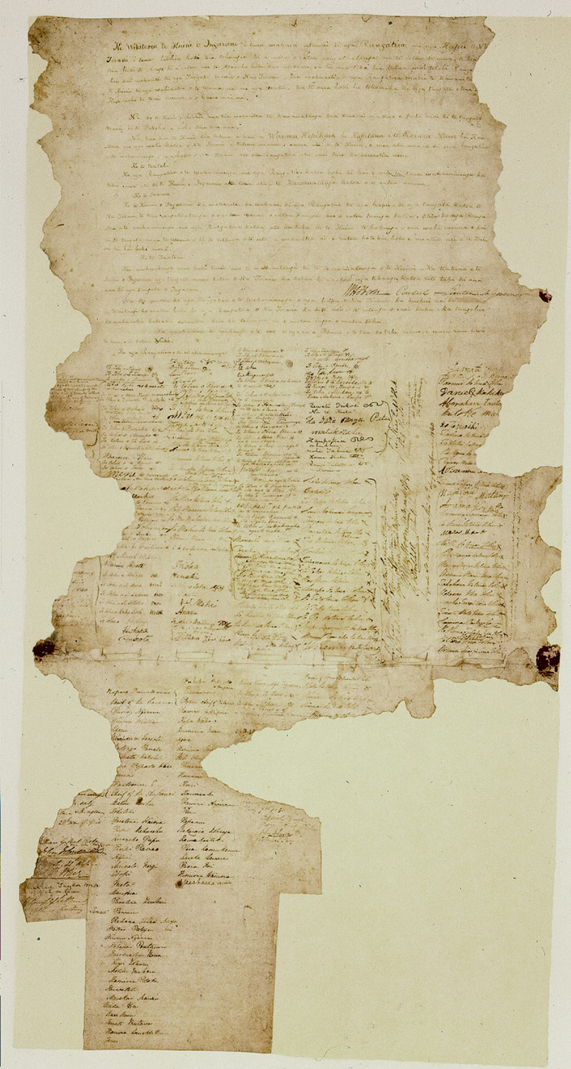
The Tiriti o Waitangi was signed on the 6 February 1840 at Waitangi. Copies of the original document were than taken around the country and signed by over 500 tangata Maori chiefs. It was then filed away where it was later damaged by fire and rats.

Official Back Translation of the Tiriti o Waitangi.

Preamble

Victoria, Queen of England, in her kind thoughtfulness to the Chiefs and Hapus of New Zealand, and her desire to preserve to them their chieftainship and their land, and that peace may always be kept with them and quietness, she has thought it a right thing that a Chief should be sent here as a negotiator with the Maoris of New Zealand - that the Maoris of New Zealand may consent to the Government of the Queen of all parts of this land and the islands, because there are many people of her tribe that have settled on this land and are coming hither. Now the Queen is desirous to establish the Government, that evil may not come to the Maoris and the Europeans who are living without law. Now the Queen has been pleased to send me, William Hobson, a Captain in the Royal Navy, to be Governor to all the places of New Zealand which may be given up now or hereafter to the Queen; and he give forth to the Chiefs of the Assembly of the Hapus of New Zealand and other Chiefs the laws spoken here.

Article One

The Chiefs of the Assembly, and all Chiefs also who have not joined the Assembly, give up entirely to the Queen of England for ever all the Government of their lands.
Article 2

The Queen of England arranges and agrees to give to the Chiefs, the Hapus and all the people of New Zealand, the full chieftainship of their lands, their settlements and their property. But the Chiefs of the Assembly, and all the other Chiefs, gives to the Queen the purchase of those pieces of land which the proprietors may wish, for such payment as may be agreed upon by them and the purchaser who is appointed by the Queen to be her purchaser.
Article 3

This is an arrangement for the consent to the Government of the Queen. The Queen of England will protect all the Maoris of New Zealand. All the rights will be given to them the same as her doings to the people of England. William Hobson Consul and Lieutenant Governor

Signed, William Hobson.
Consul and Lieutenant Governor.

Now, We the Chiefs of the assembly of the Hapus of New Zealand, now assembled at Waitangi. We, also, the Chiefs of New Zealand, see the meaning of these words: they are taken and consented to altogether by us. Therefore, are affixed our names and marks.
Done at Waitangi, on the 6 day of February, in the year one thousand eight hundred and forty, of our Lord.
Official back translation of the Tiriti o Waitangi for the Legislative Council in 1869 by Mr T E Young of the Native Department.

Queen Victoria’s Royal Charter/Letters Patent dated the 16 November 1840.
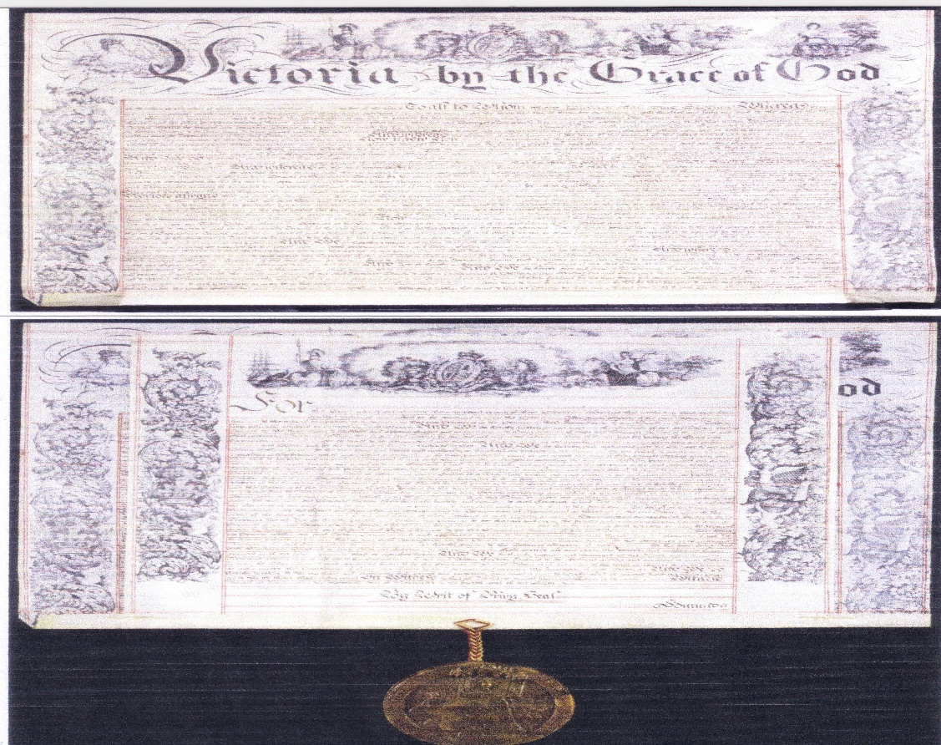
Queen Victoria’s Royal Charter/Letters Patent dated the 16 November 1840 than made New Zealand into a British Colony on the 3 May 1841 with a Governor and Constitution that set up New Zealand’s political, legal and justice systems under one flag and one law, irrespective of race, colour or creed. There is no mention of the Treaty of Waitangi in this documents.
“Our true Founding Documents and first Constitution”.
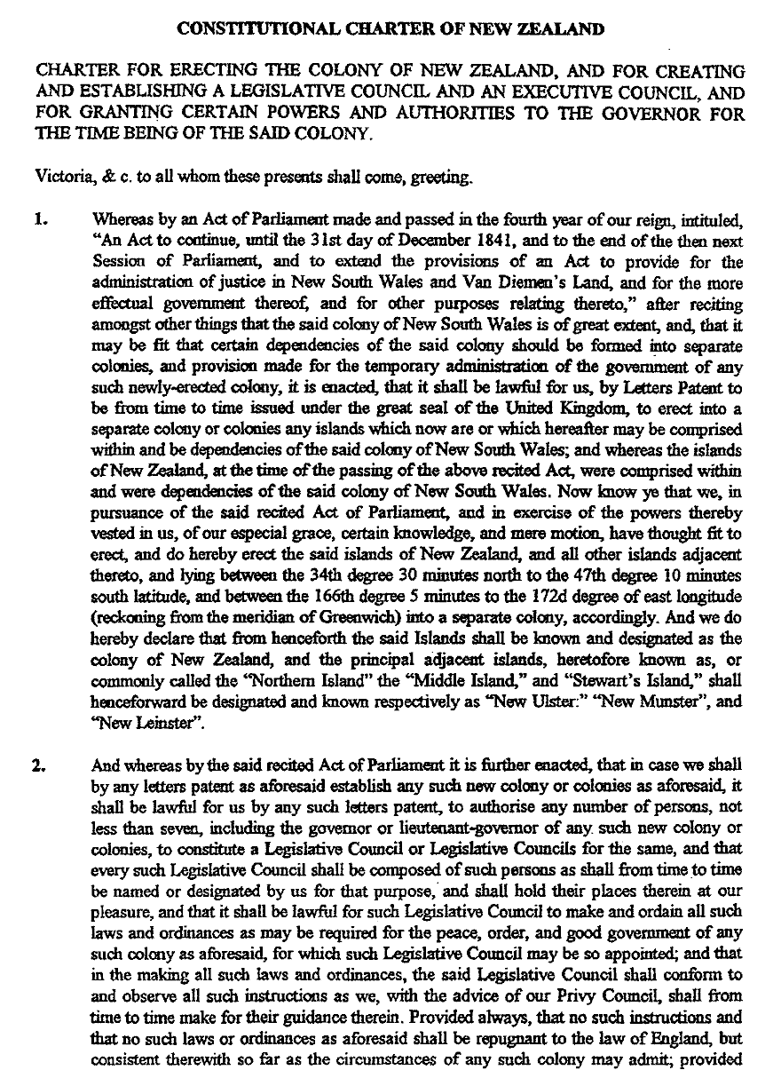
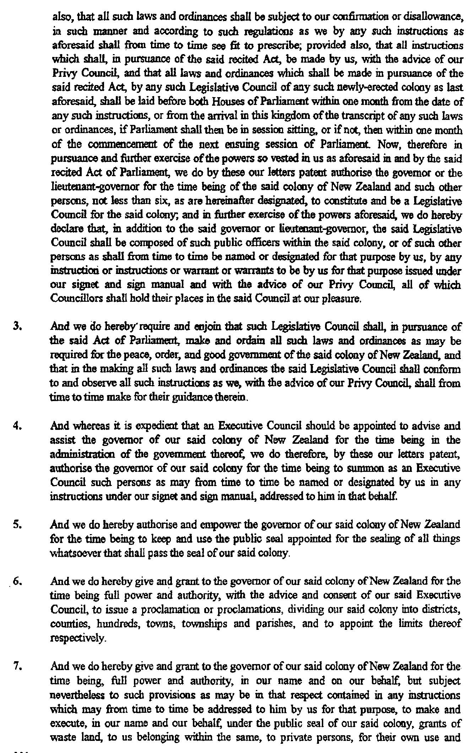
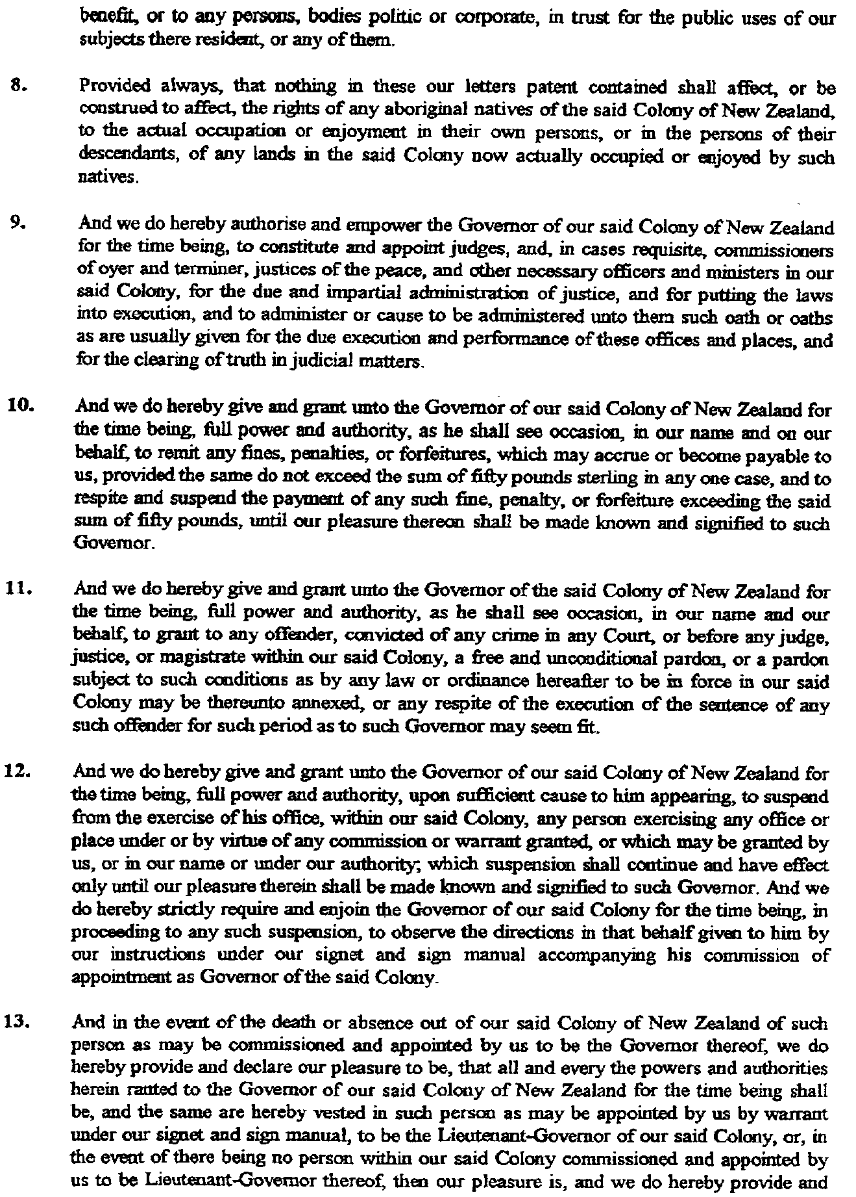
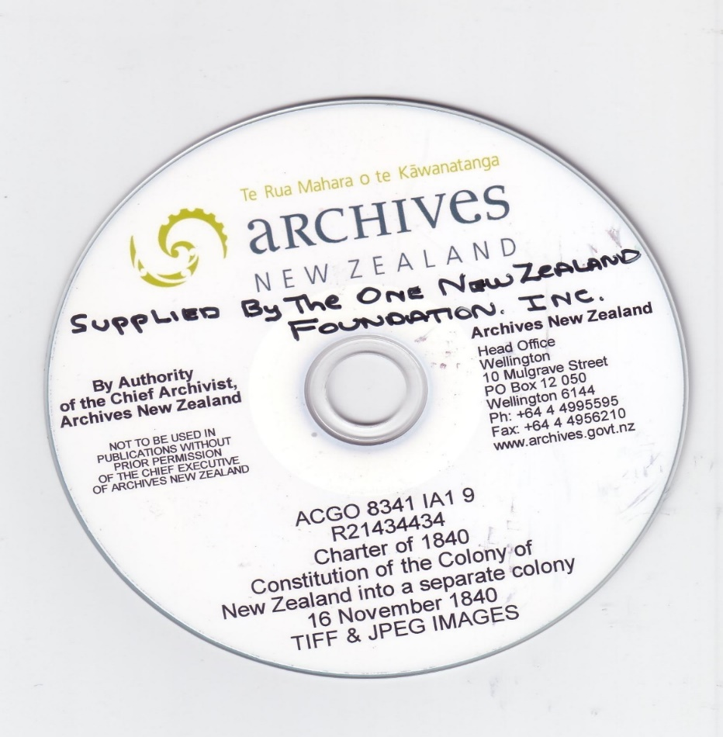
Disk supplied by the Chief Archivist, Archives New Zealand.
For documented evidence of the above: www.onenzfoundation.co.nz or ONZF@bigpond.com.au.

